Sale Extension Module Configuration

Following are the prerequisites for the Sale Extension module implementation.

- “sale_extension” module uses following 2 packages. User need to install them on Odoo server first
    - xlsxwriter
    - xlrd

- Product Line Configuration sales--->Configuration--->Settings--> Qutations and Orders

While this is true then on sale order line shows product product lines

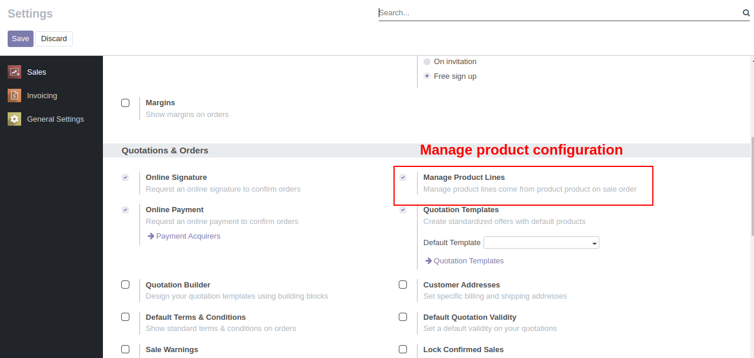

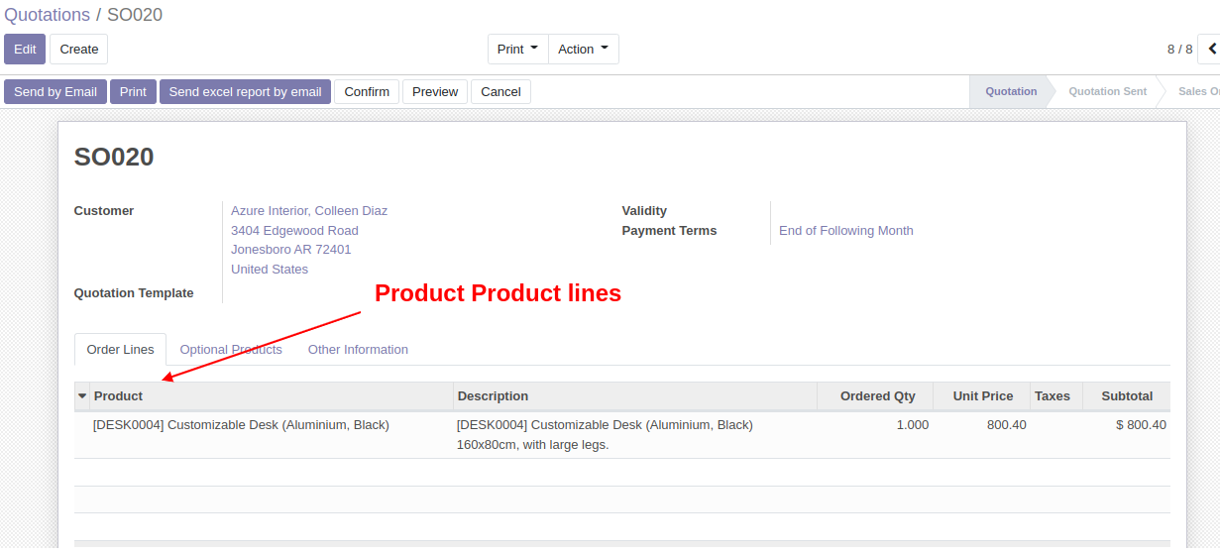

3 While when we make it False then product template lines shows
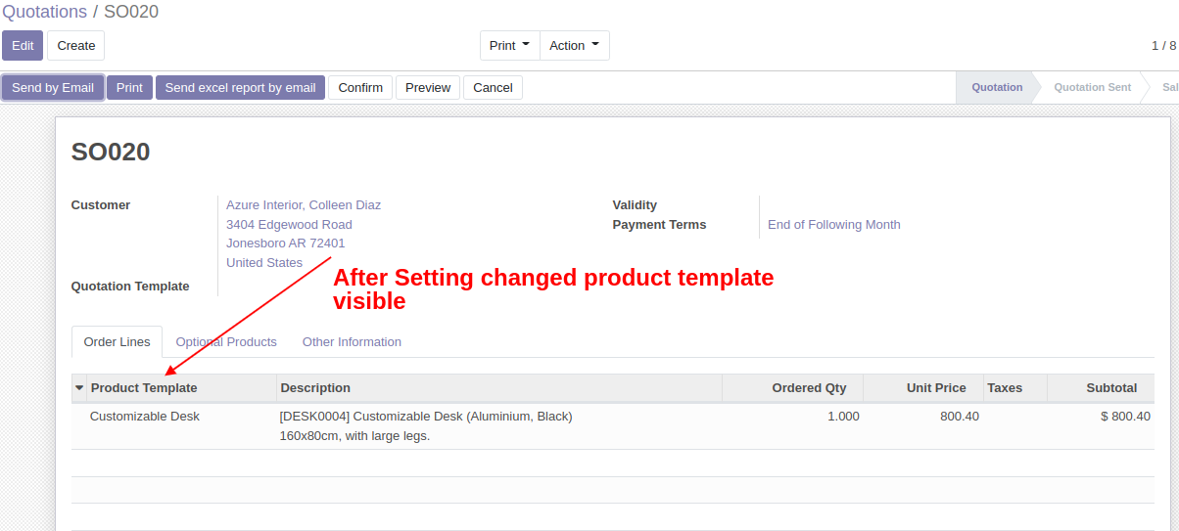

4.Created one widget similar to monetary widget, and make it available everywhere in the
database.
Widget=”Symbol”

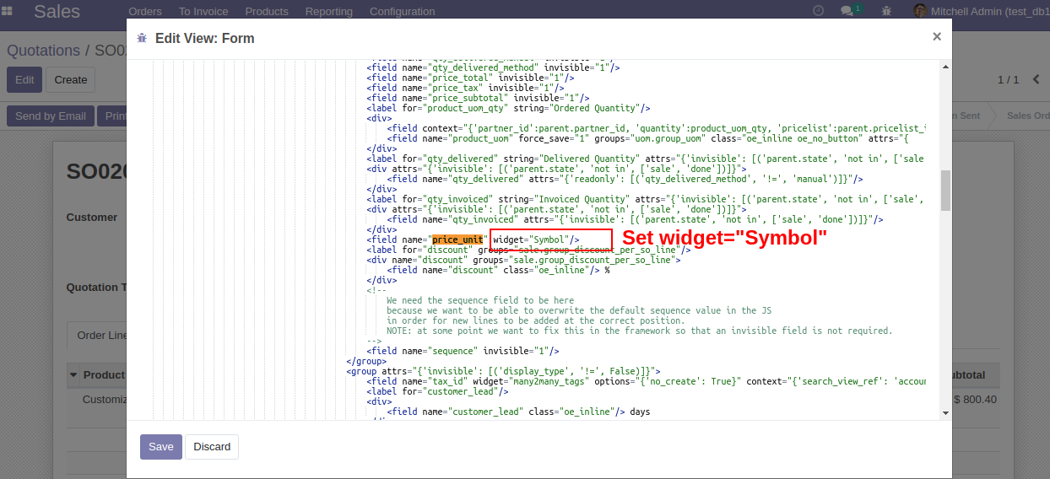
4.1 Add Widget .

Widget is added on price unit

Widget is set on price unit
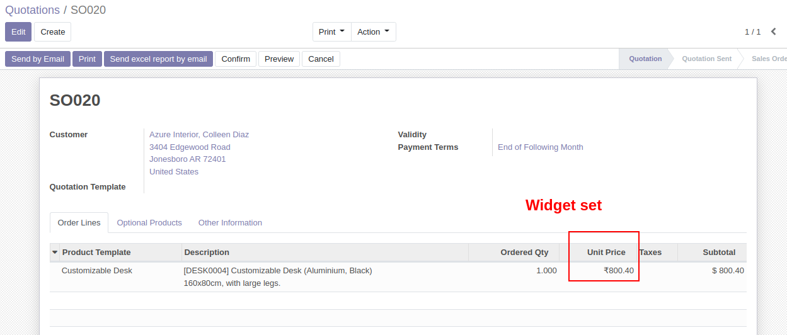

5.Duplicate the exact PDF report of sales order into an excel report.

Added a button and working functionality on form view as "send excel report by email"

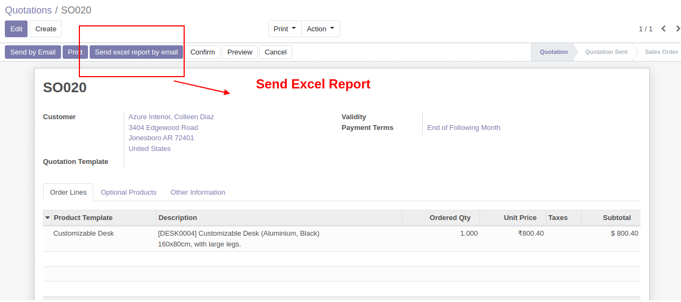

After Click on Send excel report by email

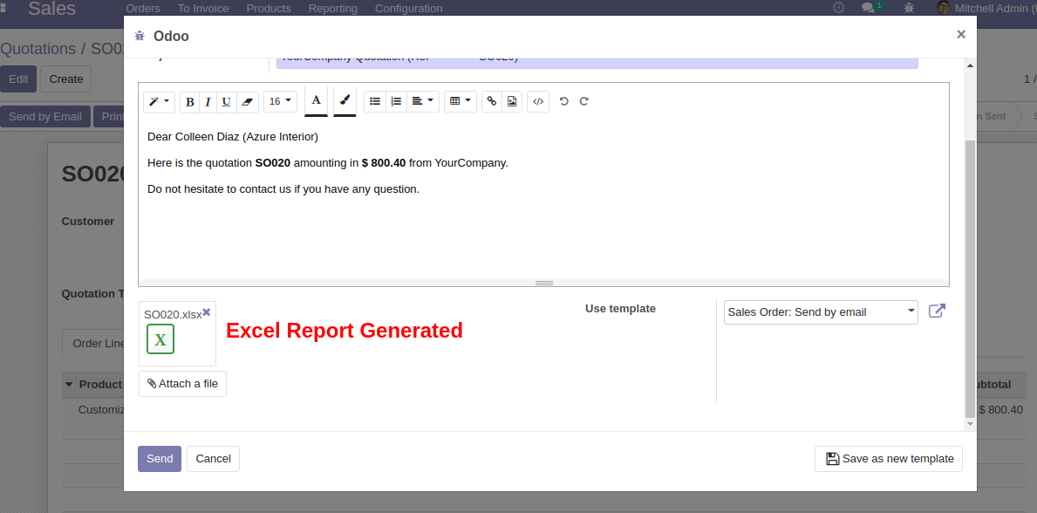

Excel Report
